Introduction
The project involves the design and implementation of three different machine learning models—Perceptron, a two-layer Neural Network, and Naive Bayes—to perform two classification tasks: recognizing handwritten digits and detecting faces in images. The models were trained and tested on separate datasets comprising scanned images of handwritten digits and pre-processed images where facial edges have been detected.
Project Overview
This project was part of the CS 440 course requirements at Rutgers University, under the guidance and structure provided by previous coursework at UC Berkeley's CS188 class. The main objective was to experiment with simple and complex models to understand their learning and generalization capabilities on optical character recognition (OCR) and face detection tasks.
Methodology
Data Preparation
The data consisted of:
- Handwritten digits from 0 to 9.
- Edge-detected images of faces.
The images were split into training, validation, and testing sets. Each model was trained progressively on 10% to 100% of the training data to observe the scalability and performance improvements.

Model Implementation
- Perceptron: Implemented using the standard learning rule; weights were updated based on prediction errors.
- Neural Network: A two-layer network with one hidden layer; used ReLU and softmax activation functions.
- Naive Bayes: Employed probabilistic reasoning for classification based on Bayes' Theorem, assuming feature independence.

Feature Extraction
- Direct pixel values were used as features for simplicity and effectiveness.
- Additional features such as pixel blocks (10x10 grids) were considered to simplify the input space and reduce dimensionality.
Results

Naive Bayes
- Digits: Accuracy improved from 69.1% to 76.3% as training data increased.
- Faces: Accuracy started at 66.0% and peaked at 94.0%, showing high effectiveness.
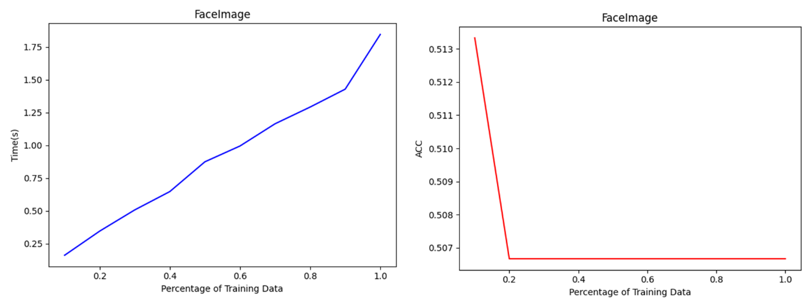
This Figure shows the changing trend of time cost and accuracy with percentage of face image training data using NaiveBayes method.
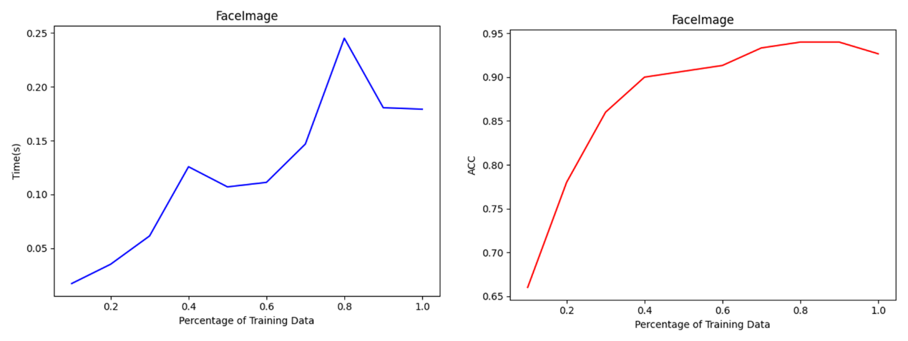
This Figure shows shows the changing trend of time cost and accuracy with percentage of face image training data using NaiveBayes method with pooling size of 3*3
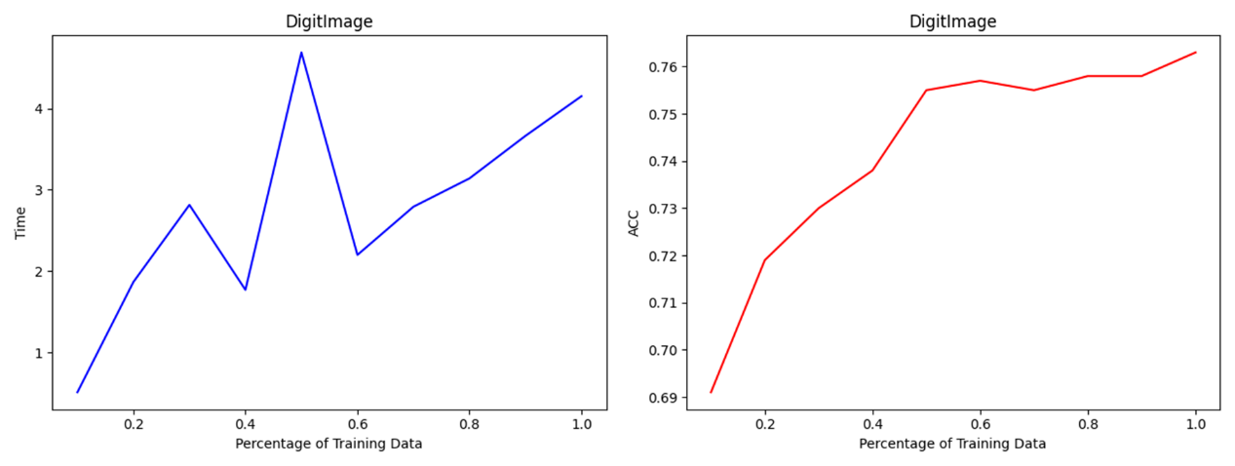
This Figure shows shows the changing trend of time cost and accuracy with percentage of Digit image training data using NaiveBayes method.

Neural Network
- Digits: Started at 76.4% accuracy with 500 training samples and reached 84.7% with 5000 samples.
- Faces: Showed significant variance, with accuracy ranging from 71.3% to 93.3%; some issues noted with potential overfitting or data anomalies.
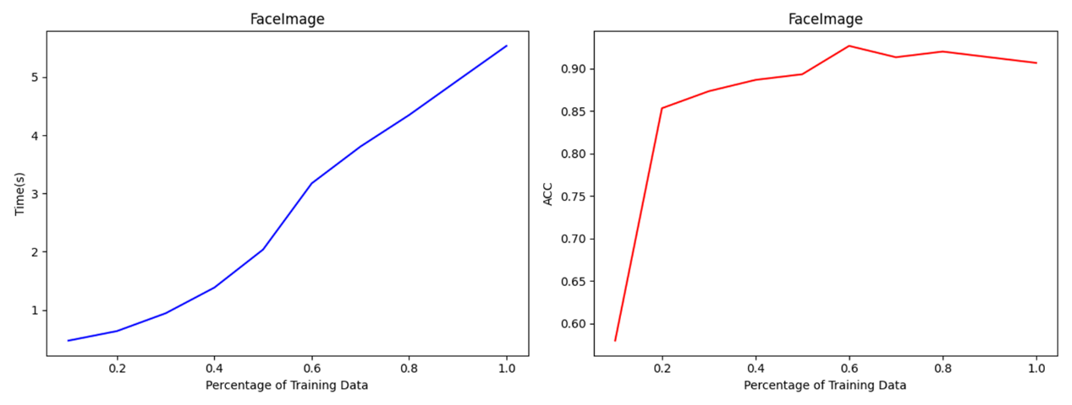
This Figure shows the changing trend of time cost and accuracy with percentage of face image training data using Neural Network method.
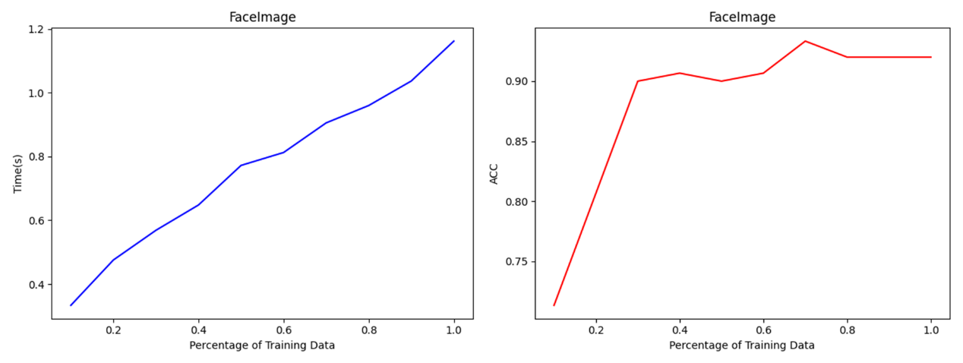
This Figure shows the changing trend of time cost and accuracy with percentage of face image training data using Neural Network method but with pooling size of 3*3.

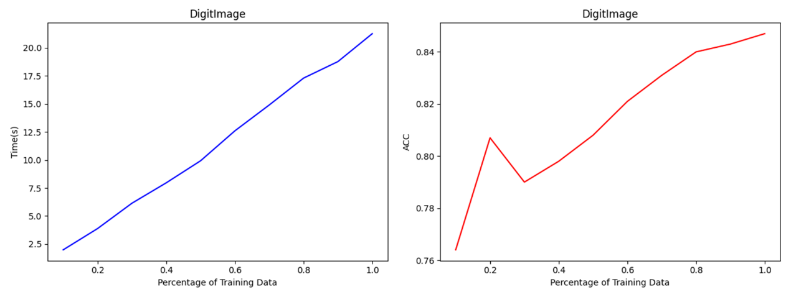
This Figure shows the changing trend of time cost and accuracy with percentage of Digit image training data using Neural Network method.
Perceptron
- Digits: High variability in performance, with accuracy peaking at 95.1%.
- Faces: Consistently improved performance, ending at 90.7% accuracy.
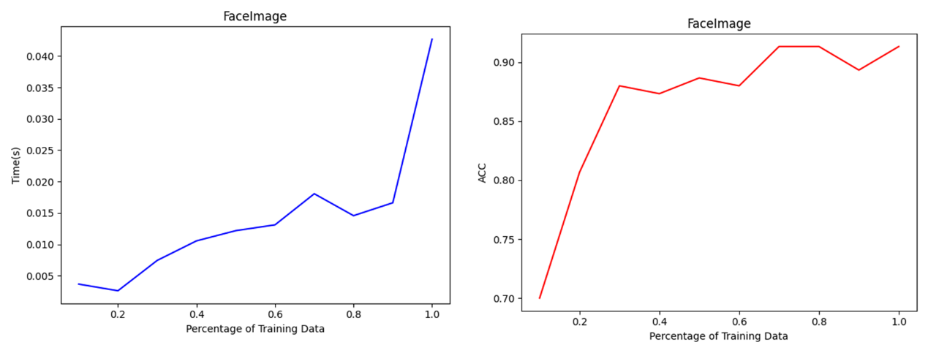
This Figure shows the changing trend of time cost and accuracy with percentage of face image training data using perceptron method.
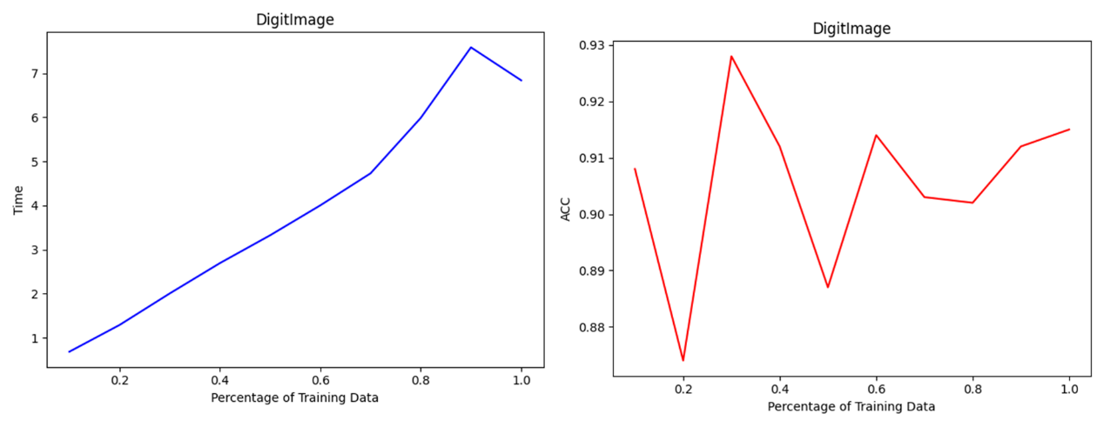
This Figure shows the changing trend of time cost and accuracy with percentage of face image training data using perceptron method but with pooling size of 3*3

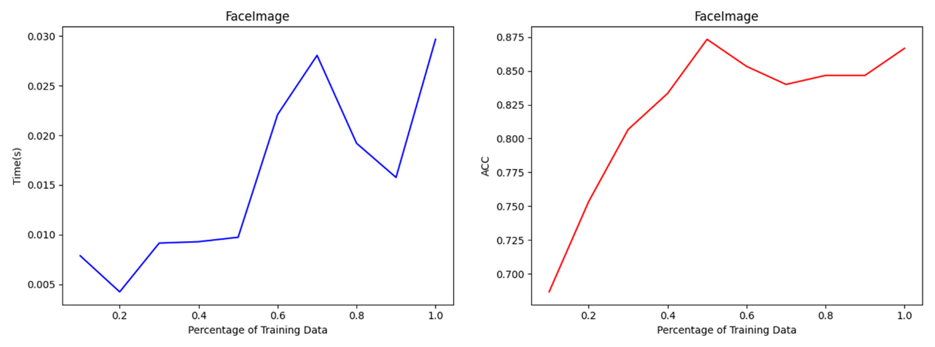
This Figure shows the changing trend of time cost and accuracy with percentage of Digit image training data using perceptron method.

Discussion
The results indicate that while simple models like Perceptron can perform remarkably well on digit classification, more complex models like Neural Networks are required to handle the nuances of face detection effectively. However, the Neural Network's performance on faces showed potential issues related to training stability and model configuration, suggesting a need for further parameter tuning and possibly more sophisticated regularization techniques.

Conclusion
This project demonstrated the application of foundational machine learning concepts to practical classification tasks. Each model offered unique insights into the challenges and complexities of pattern recognition. The progressive training approach provided valuable data on how models respond to increasing training data sizes, informing future work on model tuning and selection.

References
- Project guidelines and descriptions provided by CS 440: Introduction to Artificial Intelligence, Rutgers University.
- Previous coursework and assignments from UC Berkeley's CS188 course.

